Help Page

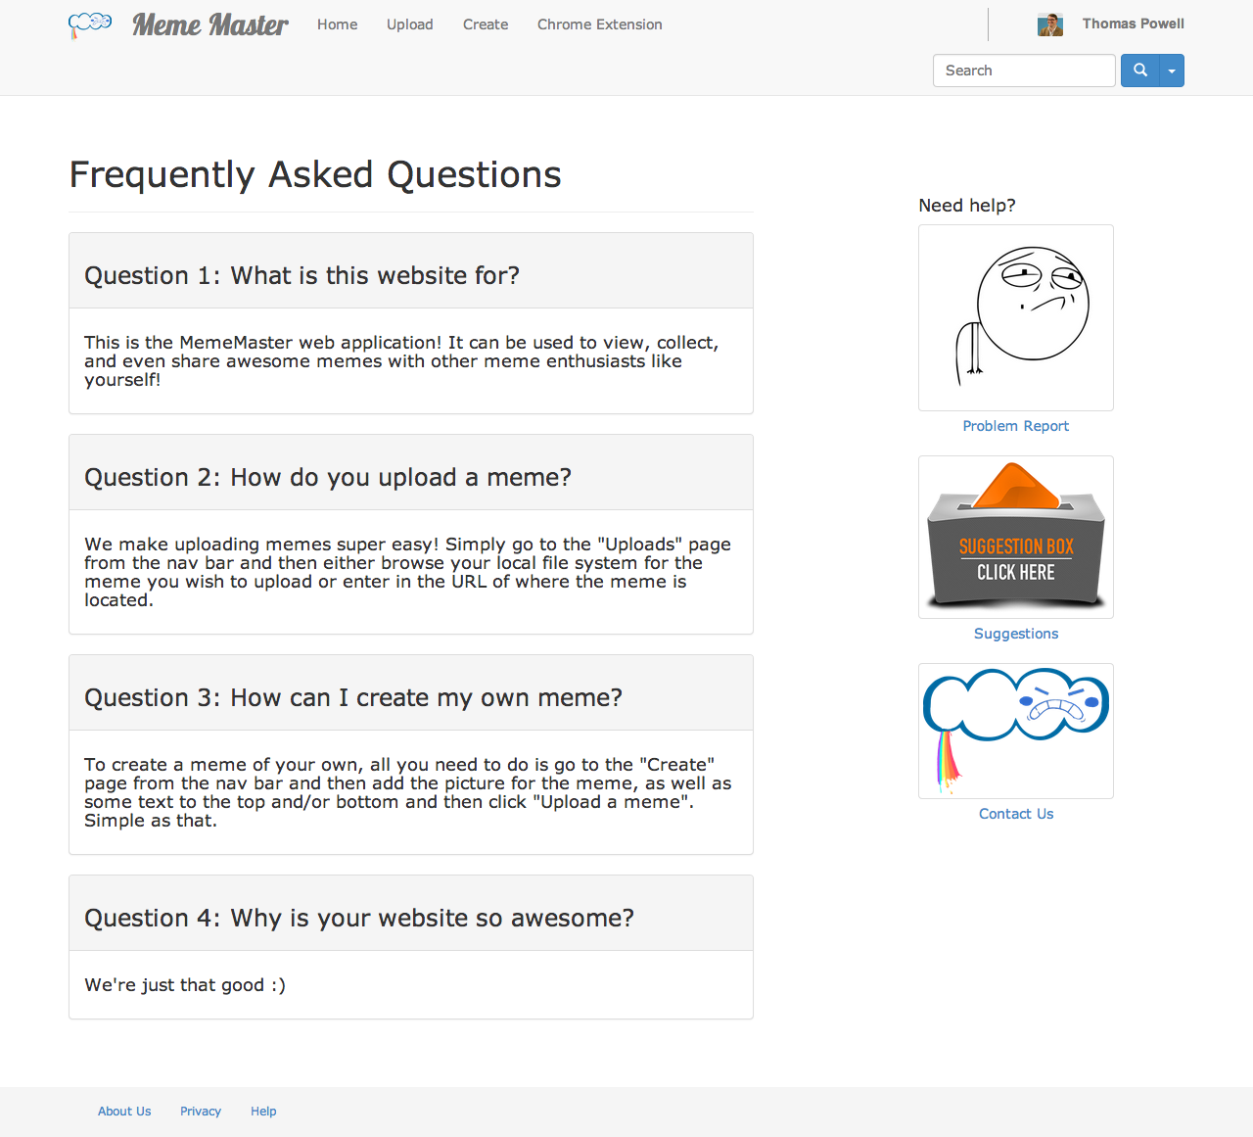

The help page is a reference page for users to access if they are new to the site and are having some difficulty getting started. The help page includes a FAQ (frequently asked questions) area, which lists some of the most popular questions asked by users. It is also the host to other helpful features such as problem reporting, user suggestions, and a contact page.

For future developments, we hope to populate the FAQ with a bunch of questions that are asked by our users as well as their answers. We are also considering adding a simple message board to the help page so other users can communicate with each other and potentially get answers to their questions even more quickly.